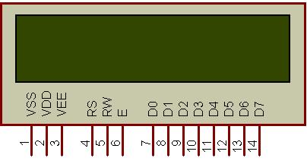

|  |  |  |
| --- | --- | --- |
| Pin | Symbol | Function |
| 1 | Vss | Ground |
| 2 | Vdd | Supply Voltage |
| 3 | Vo | Contrast Setting |
| 4 | RS | Register Select |
| 5 | R/W | Read/Write Select |
| 6 | En | Chip Enable Signal |
| 7-14 | DB0-DB7 | Data Lines |
| 15 | A/Vee | Vcc for backlight |
| 16 | K | Gnd for the backlight |